**GANPAT UNIVERSITY**

**U. V. PATEL COLLEGE OF ENGINEERING**

**B.Tech CE/IT Semester IV**

**2CEIT404: Python Programming**

**Practical-2: Basic Python Programming**

|  |
| --- |
|  |

**Q1.** Write a python program to print “Welcome to UVPCE”.

**Code :**

print("Welcome to UVPCE")

**OUTPUT :**

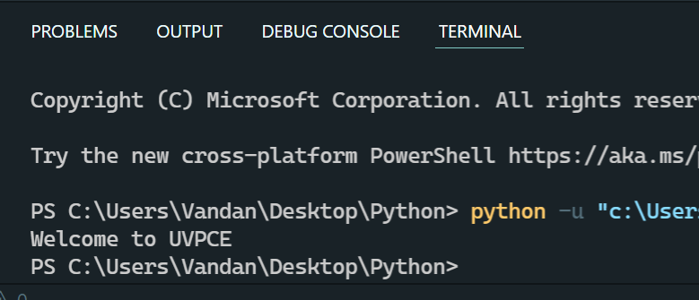

**2.** Write a python program which takes student information such as Name, Enrollment Number, Branch, Age, Email and Mobile number from user and print as following:

_________________________

Your Name

Your Enrollment No.

Branch: CE/IT

Age:XX years

Email:your mail ID

Mobile No: your No.

**Code:**

**Name = input("Your Name : ")**

**Enrollment_number = int(input("Your Enrollment_number : "))**

**Branch = input("Your Branch(CE/IT) : ")**

**Age = int(input("Your Age(Year) : "))**

**Email = input("Your Email : ")**

**Mobile = input("Your Mobile number : ")**

**print("Name: ",Name)**

**print("Enrollment_no: ",Enrollment_number)**

**print("Branch:" ,Branch)**

**print("Age: ",Age)**

**print("Email: ",Email)**

**print("Mobile: ",Mobile)**

**Output:**

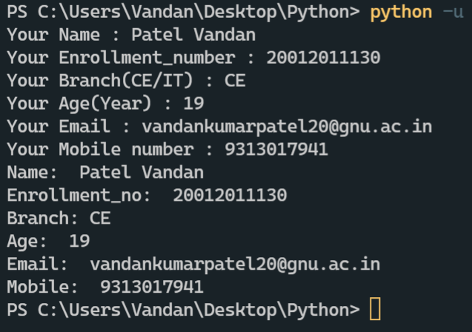

**Q3.** Write python programs to evaluate the following expressions to demonstrate the use of operator precedence and associativity.

**12 + 3 - 4 / 2 < 3 + 1**

* **False**

**X = (10 * 2) % 2 << 4++**

* **We can’t concet two similar Operator**

**Q4.** Write a python program to display data types of different variables.

**CODE :**

a = 90

b = 5.3

c = "Vandan"

d = [a,b,1]

e = (3,9,[a,5,6,7])

print(type(a))

print(type(b))

print(type(c))

print(type(d))

print(type(e))

print(type())

**Output:**

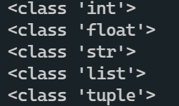

**Q5.** Write a python program to check given character is a vowel or not.

**CODE :**

str = input("Enter your character : ")

*if*(str == "a" or str== "A" or str== "e" or str== "E" or str== "i" or

 str== "I" or str== "o" or str== "O" or str== "u" or str== "U" ):

    print("You Entered a VOWEL!")

*else*:

    print("You entered consonant")

**Output:**

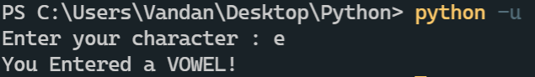

**Q6.** Write a python program to for library charges a fine for books returned late. Following are the fines:

First five days: 40 paisa per day.

Six to ten day: 65 paisa per day.

Above ten days: 80 paisa per day

**CODE :**

days = int(input("Enter number of days you are late to submit books : "))

*if*(days <= 5):

    amount = days * 4

*elif*(days >= 6 and days<=10):

    amount = (5*0.4) + (days-5)*0.65

*else*:

    amount = (5*0.4) + (5*0.65) + (days-10)*0.8

print("Your fine for {} days delay is {}".format(days,amount))

**Output:**

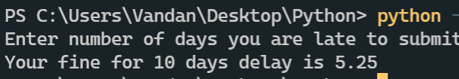

**Q7.** Write a python program to count odd numbers from given three numbers and display maximum odd number.

**CODE :**

x,y,z = 1,2,3

count = 0

*if*(x%2 == 1):

    count+=1

*if*(y%2 == 1):

    count+=1

*if*(z%2 == 1):

    count+=1

*if*(count == 0):

    print("All values are even")

*else*:

    print("Total odd values = {}".format(count))

**Output:**

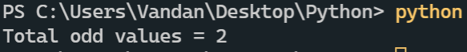

**Q8.** Enter the following statements into the interpreter and note which ones produce an error, give reason for error:

* str1 = “welcome”

print (str1*2)

str1="Welcome"

print (str1*2)



* 2) 15 % 12



* 3) print (18.0 // 4)

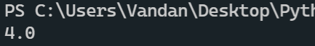

* 4) 7<=7

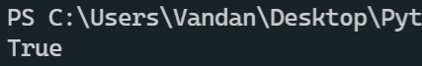

* 5) -1<>-1.0

**Error**

**Because we have to put arguments between < >**

* 6) -5 is -5.0

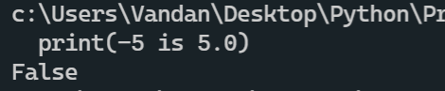

“is” is not a operator,”==” instead of “is”

* 7) print( ‘Steve's “ Laptop”’)

**Error**

**Because ‘ not ended properly**